**Unity Post Processing**

**Objective:** In this lesson students are going to learn how to add post processing effects to change the look of our game.

<https://docs.unity3d.com/Manual/PostProcessingOverview.html>

1. Go to **Window > Package Manager**
2. Switch to **Unity Registry**
3. Look for **Post Processing**
4. Install
5. Create **Empty GameObject** and name it **Post Processing** reset its position
6. Click Add Component and look for **Post-Processing Volume**

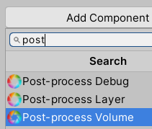

1. Make sure Is Global is checked



1. Right click in your **Assets** folder and look for **Create > Post Processing Profile**

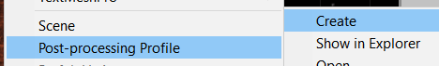

1. Name it **GLobalPP**



1. Click on the **Post Processing** GameObject in the Hierarchy and for **Profile** drag your **GlobalPP** to this field.



1. We also need to change the Layer so the Camera knows what layer to look at. Click on **Default > Add Layer**

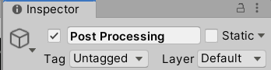

1. Find the first available layer and type Post Processing



1. Click on **Post Processing** in the hierarchy and change layer to this new layer.
2. Click on your Main Camera and **Add Component**>**Post-process Layer**
3. Change this components Layer to **Post Processing**

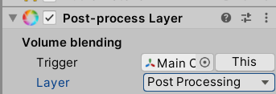

1. Change **Mode** to **Fast Approximate Anti-Aliasing**



1. Make sure **Fast Mode** is checked 

This will make it not look as good but run better. Feel free to not do this.

1. Make a prefab out of the **Player Rig** and **Post Processing**
2. Click on **Post Processing** and click on **Add Effect > Unity> Bloom**

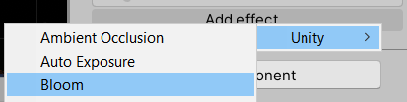

1. Click on **All** inside of Bloom to turn everything one



1. Increase **Intensity** **to 7** to see the changes. You see things get brighter
2. If you change **Soft Knee** this gives you some haziness
3. Feel free to mess with these settings to see what works for your game. Also Add more Effects to see what you like.
4. I added **Vignette** and changes the **Intensity** to **0.47** and **Smoothness** to **0.16.** I found that this kind of focused the Players attention to the middle
5. I also added **Ambient Occlusion**. This affects the shadows where there’s no light. You can change the intensity to make it a little more dark. Set **Intensity to 0.85** and **Thickness to 1.84**
6. **Auto Exposure** which helps make this a bit more bright
7. **Color Grading** helps change the Temperature of your world

**Final thoughts:**

* create a 3 minute experience.
* Remember it doesn’t have to be ALL action all the time.
* Create a beat chart to know how the game plays out.
* Don’t be afraid to go around the Terrain multiple times.
* Have your enemies from your first wave come back around later on that way if you didn’t destroy all of them it affects the player later on.

Possible Bug:

Finally if your Trees are interfering with hit detection go to your **Terrain** and in your **Terrain Collider** **turn off Enable Tree Colliders**